Symbiosis Institute of Technology, Pune



Department of Applied Science
First Year B. Tech Academic Year: 2026-27

EDP Lab Project Report

Library Management System

By:
1. Ayush Dumbre (25070123029)
2. Ayush Phale (25070123028)
3. Bidisha Chaudhuri (25070123034)
Batch-ENTC A2

Faculty Incharge: Dr. Snehal Bhosale

ACKNOWLEDGEMENT

We are thankful to our EDP Teacher, Snehal Bhosale sir, for his continuous support and guidance in the completion of this Python project. His valuable input and constructive feedback greatly enhanced the quality and depth of this project. We also want to express our sincere gratitude to the college administration for providing the required facilities, software tools, and resources needed for the successful completion of this project.

We are appreciative of our parents and friends for their constant encouragement, moral support, and assistance throughout the duration of the project. Their unwavering support was essential in making this project comprehensive and informative. Additionally, we wish to acknowledge the various online resources, Python documentation, and reference materials that helped us gather relevant data and implement the required functionalities.

INTRODUCTION

In this Python project, we have developed a Library Management System that effectively manages book issuance, returns, and record-keeping for a college library. The system is built using Python programming language and leverages powerful libraries such as Pandas, NumPy, Matplotlib, PrettyTable, and Yagmail to provide a comprehensive and automated library solution.

The system maintains two core CSV-based databases: a Library Records file to track currently issued books, and a Late Submission Records file to log overdue returns and associated penalties. Upon book issuance, the system records student details including Unique ID, Name, Department, Year of Study, Book Serial Number, and dates of issue and return. The system also calculates late fees at Rs. 10 per day and sends automated email receipts to students.

Beyond core library operations, the project includes multiple data analysis experiments (Experiments 10 through 18) that analyze the library dataset using statistical methods, data preprocessing techniques, normalization, and a wide variety of visualizations including bar charts, histograms, pie charts, heatmaps, treemaps, Sankey diagrams, and 3D scatter plots.

OBJECTIVE OF THE PROJECT

- Library Operations Automation: Build a menu-driven system to issue and return books, automatically recording student details, issue dates, and due dates.
- Late Fee Management: Automatically calculate and record late fees at Rs. 10 per day for overdue returns, maintaining a separate Late Submission Records database.
- Email Notification System: Send automated email receipts to students on book issuance and return using the Yagmail library with Gmail SMTP.
- Data Analysis & Preprocessing: Perform categorical data analysis, handle missing values, remove duplicates, apply normalization (Min-Max, Z-Score, Decimal Scaling), and conduct data binning and formatting.
- Data Visualization: Generate a comprehensive set of charts and graphs including bar charts, pie charts, histograms, scatter plots, box plots, heatmaps, area plots, treemaps, Sankey diagrams, dendrogram, radar charts, and 3D scatter plots to derive insights from library data.

RAW DATA

The Library Management System operates on a dataset of approximately 500 student records stored in CSV format (/content/Library_records_500.csv). The dataset was generated using a combination of real-world inputs and the RANDBETWEEN equivalent in Python (numpy.random) to simulate realistic library usage patterns. A secondary dataset (/content/LATE_submission_Records.csv) tracks overdue book returns.

The primary dataset contains the following columns:

Column Name | Description
unique id | Unique identifier for each student
name | Full name of the student
year of study | Current year of study (1st, 2nd, etc.)
department | Student's engineering department
book serial no. | Serial number of the issued book
book name | Title of the issued book
date of issue | Date when book was issued (YYYY-MM-DD)
submit date | Due date for returning the book
phone no. | Contact number of the student
email id | Email address for receipt delivery

Below is a reference screenshot of the raw dataset loaded in the system:
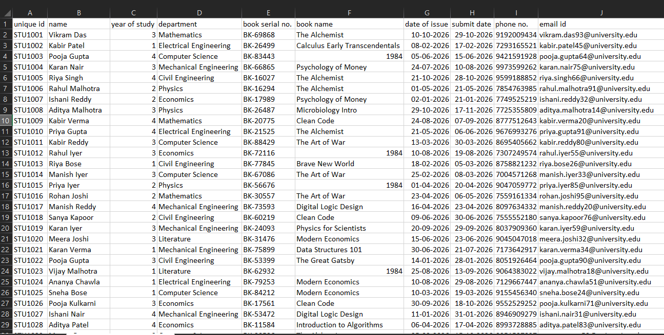

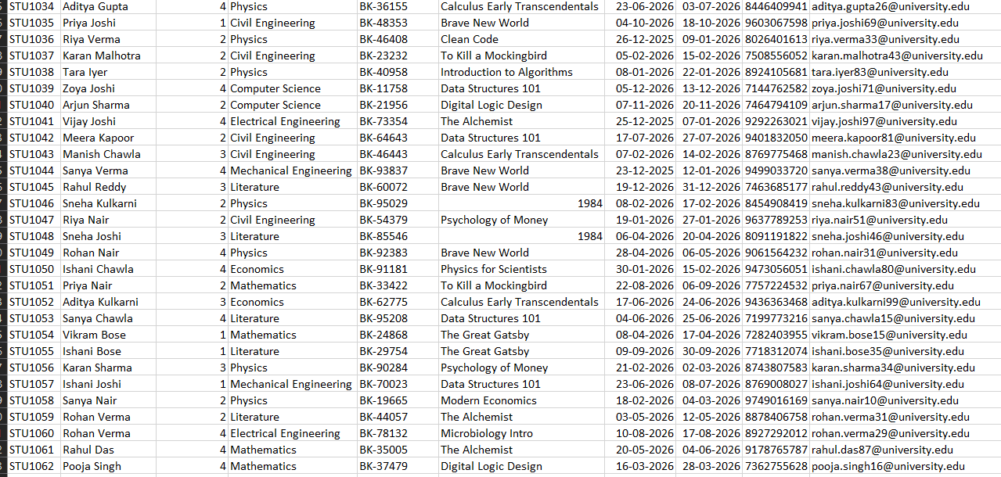
LIBRARIES USED

The project makes use of several powerful Python libraries to deliver its full functionality. Each library plays a distinct role in the system:

1. Pandas
Pandas is the primary data manipulation library used in this project. It is used to load, clean, filter, and save CSV files. DataFrames are used to represent all library and late submission records. Key operations include read_csv(), fillna(), dropna(), drop_duplicates(), pivot_table(), and value_counts().

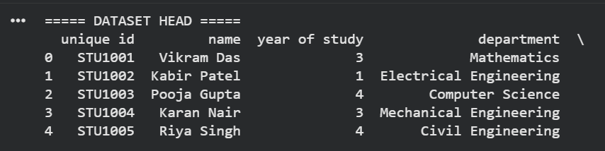
2. NumPy
NumPy provides numerical computing capabilities. It is used to handle numeric column selection (select_dtypes), compute statistical measures, and support array operations required by scikit-learn preprocessing functions.

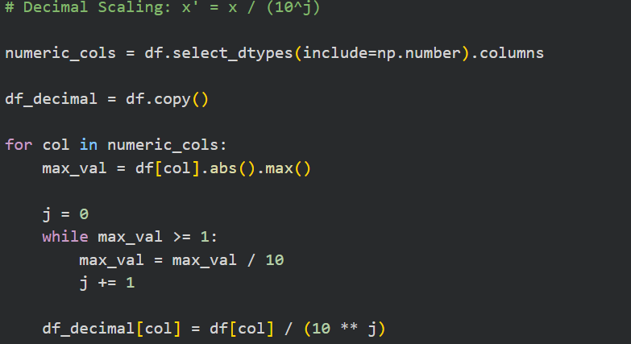
3. Matplotlib
Matplotlib is the core visualization library. It is used to generate bar charts, pie charts, histograms, scatter plots, box plots, area plots, and bubble charts from the library dataset, providing visual insights into book borrowing patterns and departmental usage.

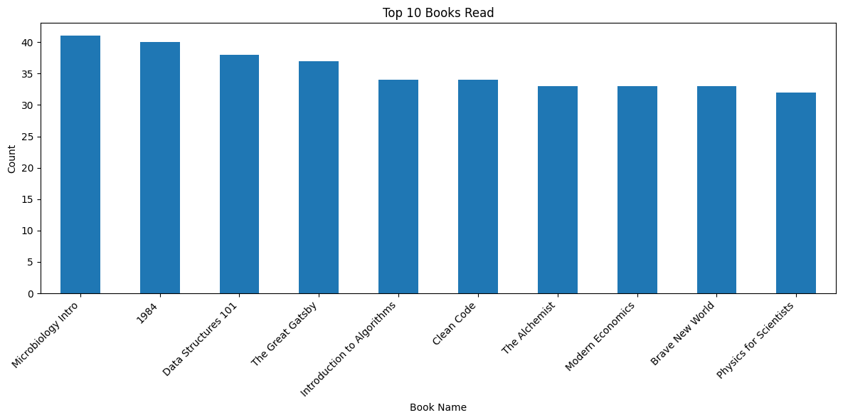
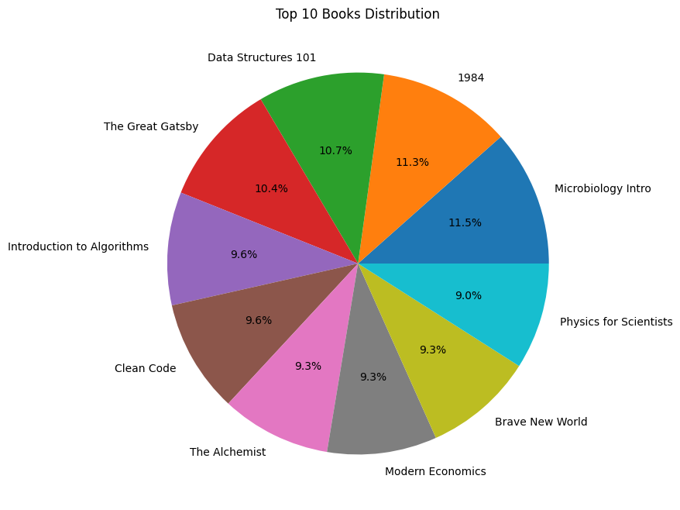
4. Seaborn
Seaborn is used for statistical data visualization, specifically to create heatmaps. The heatmap displays the relationship between library books and student departments, with annotated values for easy interpretation.

5. Plotly
Plotly is used to generate interactive and advanced visualizations including Treemaps (hierarchical view of books within departments), 3D Scatter Plots (three-variable relationships), Radar Charts (department vs. book distribution), and Sankey Diagrams (flow of books across departments).
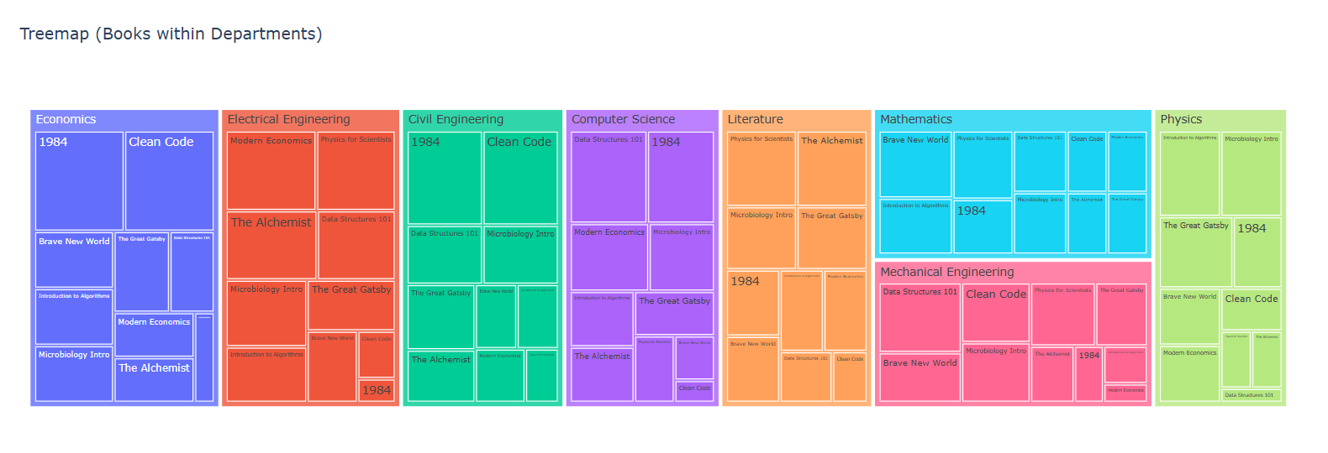

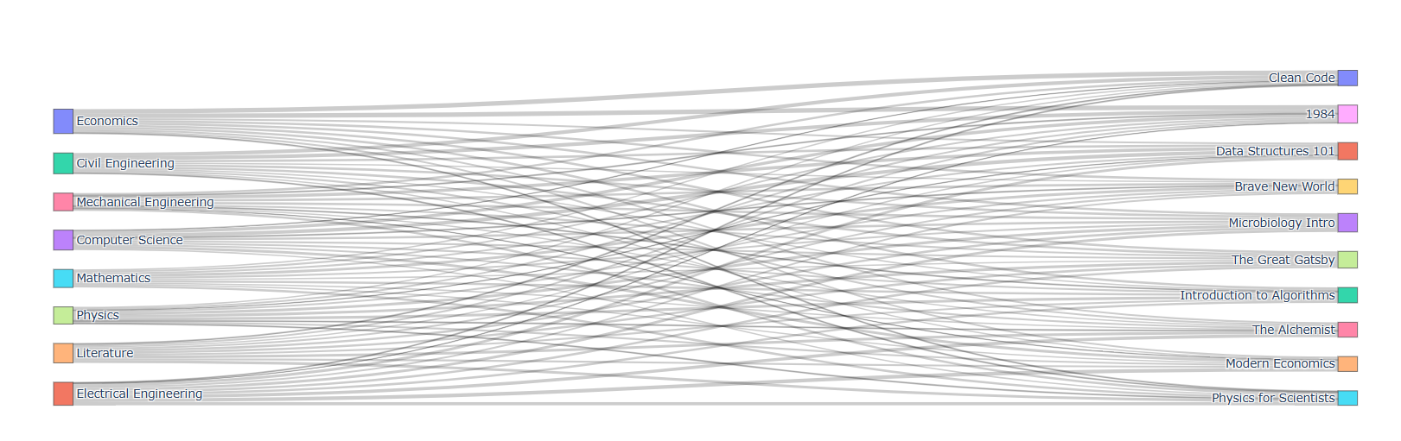
6. Scikit-Learn (sklearn)
Scikit-learn's preprocessing module is used for data normalization. Min-Max Scaler normalizes numeric values to a [0,1] range, while StandardScaler applies Z-Score standardization (mean=0, std=1). LabelEncoder is used to convert categorical text columns to numeric codes.
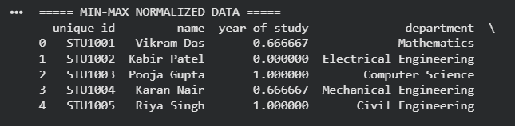

7. PrettyTable
PrettyTable is used to display tabular data in a clean, formatted ASCII table directly in the console. It is used in the book return workflow to display matching records, showing Row#, Unique ID, Name, Book Serial, Book Name, and Due Date in an easy-to-read format.
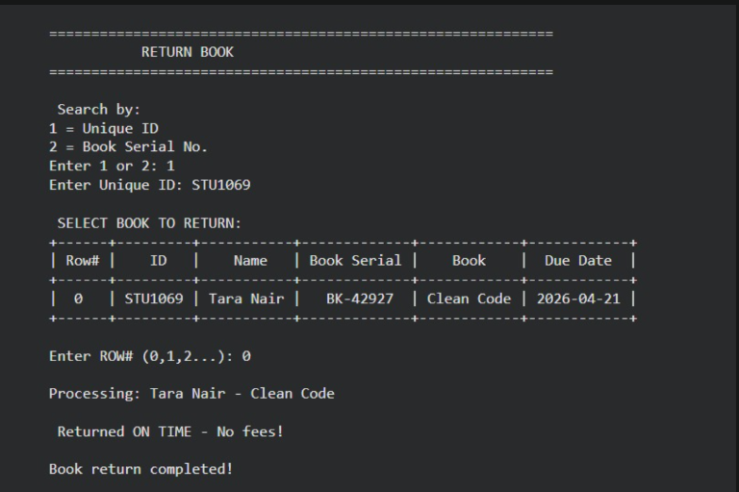

8. Yagmail
Yagmail provides a simplified interface for sending emails via Gmail's SMTP server. It is used to automatically email book issuance and return receipts to students. The librarian's credentials are securely stored using Google Colab Secrets (userdata.get).

9. SciPy
SciPy's hierarchical clustering module (scipy.cluster.hierarchy) is used to generate Dendrograms that visualize the hierarchical clustering of library departments based on their book borrowing patterns. The Ward linkage method is applied for minimum variance clustering. 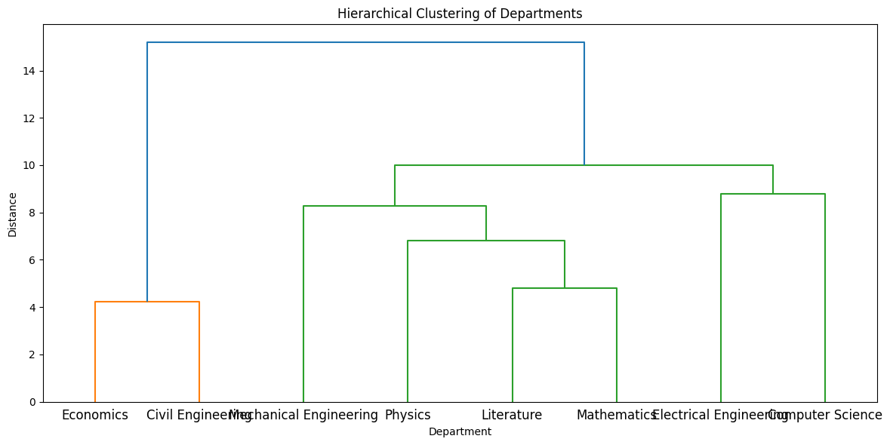

FUNCTIONS USED

The project uses a wide range of Python built-in functions, Pandas methods, and custom-defined functions to implement the Library Management System and the accompanying data analysis experiments. The key functions are described below.

1. load_library_records() / load_late_records()
These utility functions load the CSV-based library and late submission databases using pd.read_csv(). If the files do not exist, they return empty DataFrames with pre-defined column structures. Column names are stripped of whitespace and key ID columns are cast to string type to prevent type mismatches during lookups.
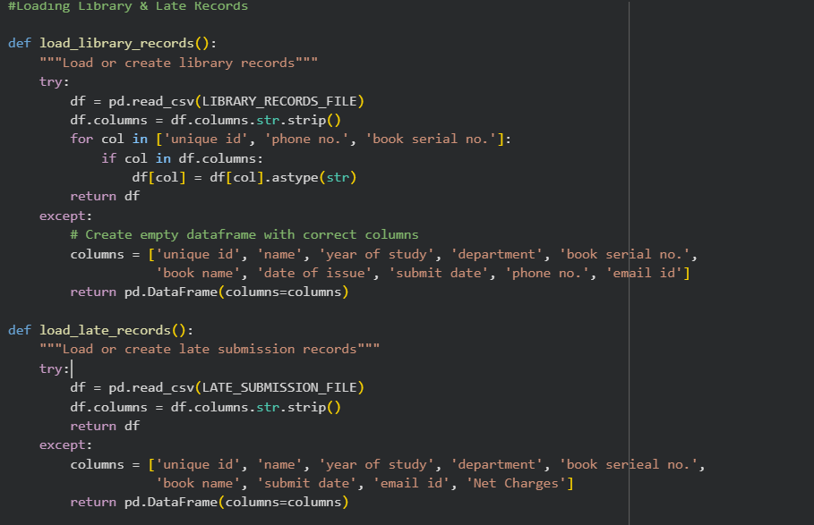

2. save_library_records() / save_late_records()
These functions persist updated DataFrames back to their respective CSV files using df.to_csv() with index=False. They include exception handling to gracefully report any file save failures.

3. issue_book()
This is the primary book issuance function. It collects student and book details via console inputs, calculates the issue date (today) and due date (today + allowed days), checks whether the student already exists in the database, and either updates the existing record or appends a new one. A formatted receipt is generated and optionally emailed to the student.
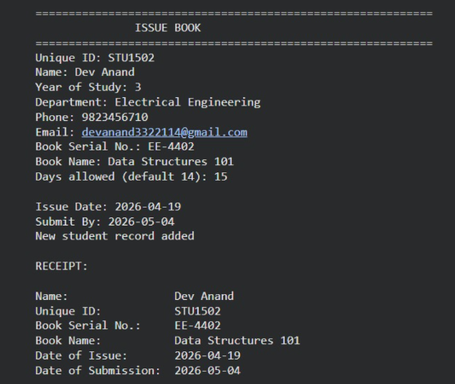

4. submit_book()
This function handles book returns. It searches for records by Unique ID or Book Serial Number, displays matching results in a PrettyTable, and processes the selected record. Late fees are calculated at Rs. 10 per day for any return past the due date. The record is removed from the Library Records file and, if overdue, added to the Late Submission Records.
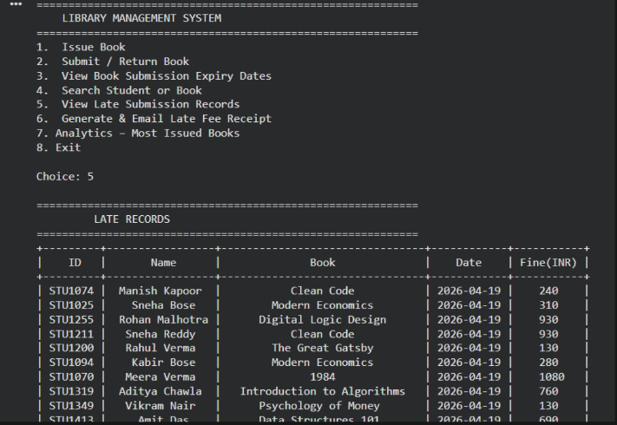

5. format_receipt()
This function generates a structured text receipt containing student name, unique ID, book serial number, book name, date of issue, submission date, and optionally the late fee. The receipt format matches the prescribed institutional template.

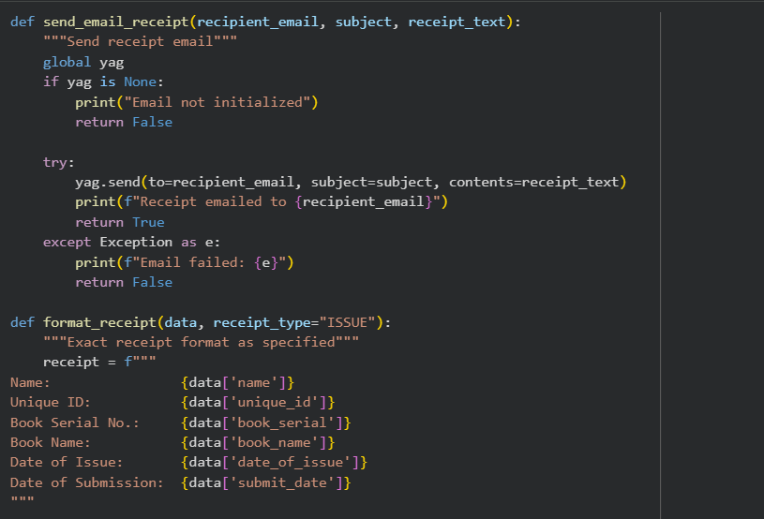

6. send_email_receipt()
Using the initialized Yagmail SMTP connection, this function sends the formatted receipt as an email to the student's registered email address. It returns True on success and False on failure, with appropriate error messages displayed.

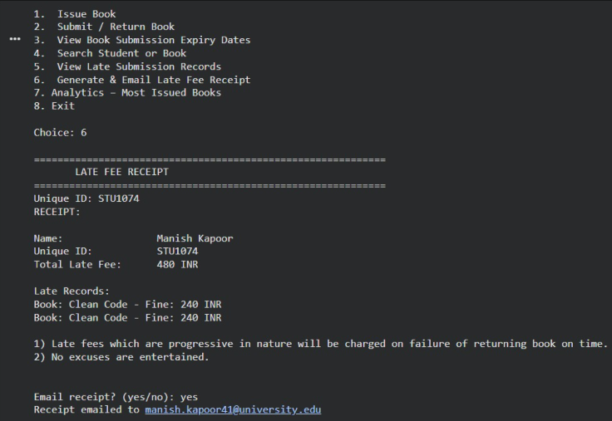

DATA ANALYSIS EXPERIMENTS

Experiment 10: Loading and Exploring the Dataset
The library dataset is loaded using pd.read_csv(). The head(), describe(), info(), and isnull().sum() methods are used to explore the dataset's structure, data types, and missing values. Missing numeric values are filled using the column mean.
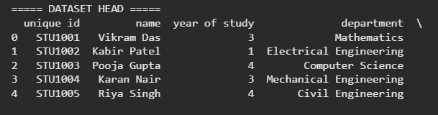

Experiment 11: Categorical Data Analysis
Categorical columns are identified using select_dtypes(include='object'). LabelEncoder converts text categories to numeric codes. One-Hot Encoding (get_dummies) creates binary indicator columns. The most frequent category is used to filter a subset of records.

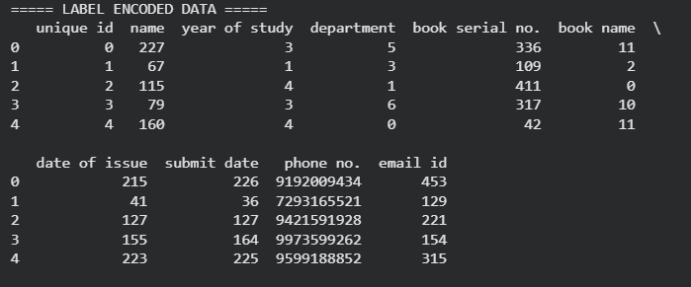

Experiment 12: Data Preprocessing and Missing Value Treatment
Missing values are counted, then handled using dropna() and fillna() (mean for numeric, mode for categorical). Duplicate rows are removed using drop_duplicates(). Min-Max Scaling is applied to numeric columns using MinMaxScaler from scikit-learn.

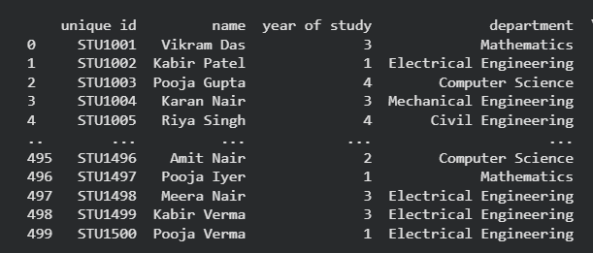

Experiment 13: Data Binning and Formatting
A pivot table is created from the library dataset grouping books by department. The top departments and top books are filtered for cleaner visualization. Multiple chart types are generated: line plots, bar charts, and histograms using this pivot data.

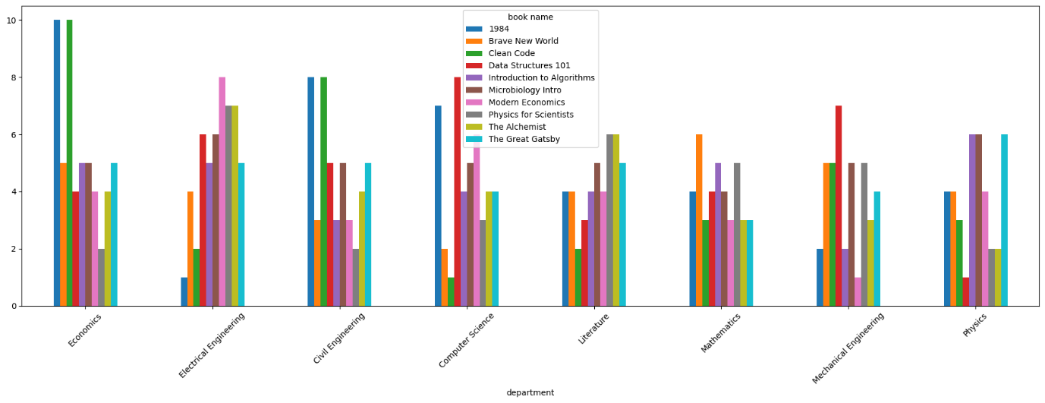

Experiment 14: Data Normalization and Type Conversion
Min-Max Normalization scales values to [0,1]. Z-Score Standardization centers data around mean=0 with std=1. Decimal Scaling divides values by the appropriate power of 10. Min/Max values are printed before and after normalization for comparison. Multiple numeric columns are normalized simultaneously.

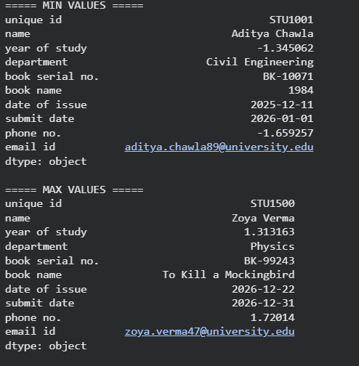

Experiment 16: Basic Visualizations
This experiment generates five core chart types: a Bar Chart showing book borrowing frequency by title, a Pie Chart showing proportional book distribution, a Bar Chart of student counts by department, a Histogram of numeric columns, and a Scatter Plot. Color encoding by department is also applied to the bar chart.





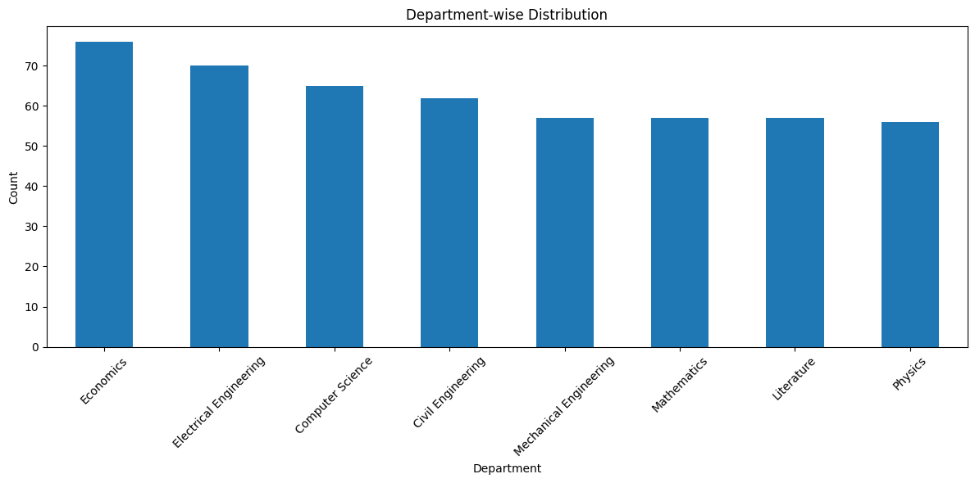

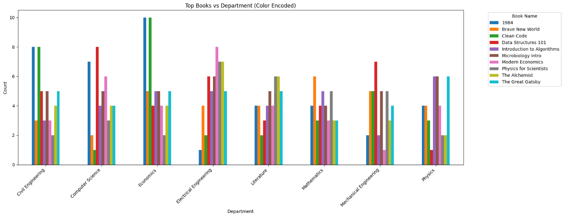

Experiment 17: Advanced Statistical Visualizations
Statistical measures — Mean, Median, and Mode — are computed on numeric columns. Advanced chart types are generated: Area Plot (stacked=False), Box Plot (to show distribution and outliers of top books across departments), Heatmap (using Seaborn with annotation), and Bubble Plot (three-variable relationship visualization).

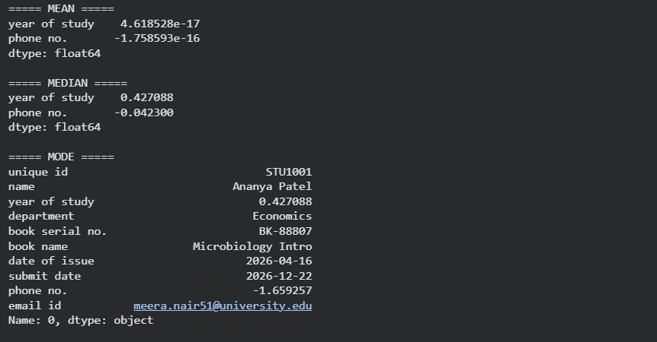

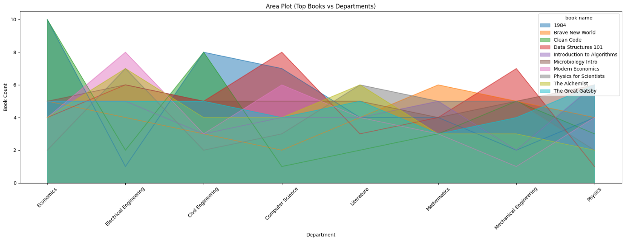

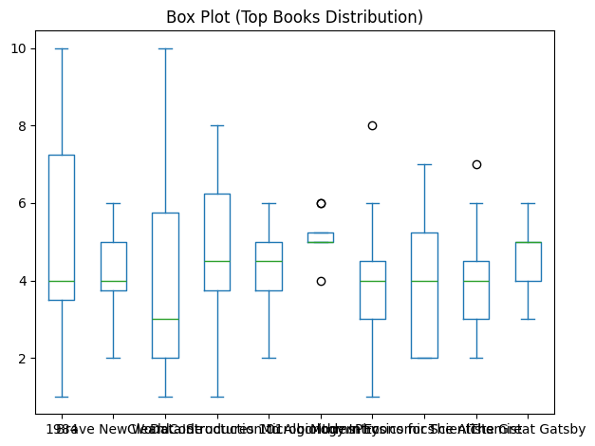

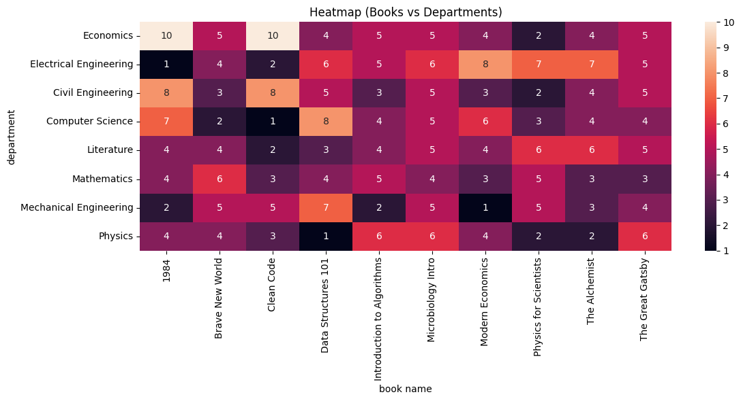

Experiment 18: Real-World Interactive Visualization
Interactive and advanced visualizations are generated using Plotly and SciPy: a Treemap showing books nested within departments, a Dendrogram of hierarchical clustering of departments (Ward linkage), a Sankey Diagram showing book flow, a 3D Scatter Plot, and a Radar Chart showing one department's book distribution across categories.

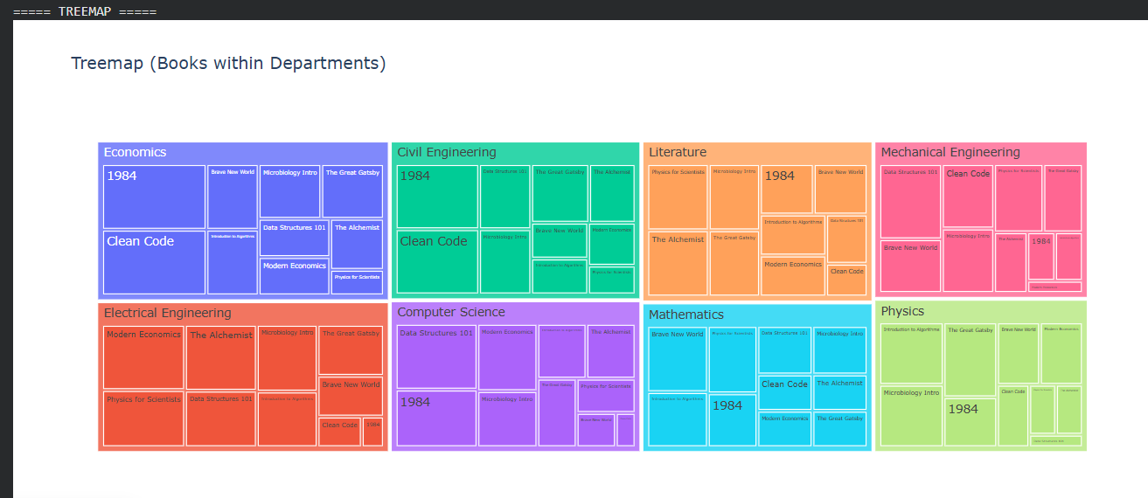



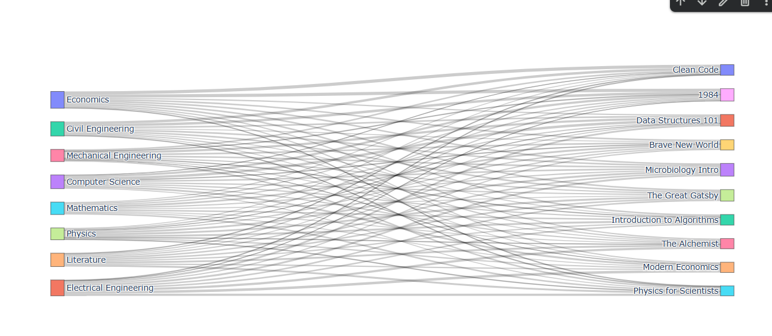

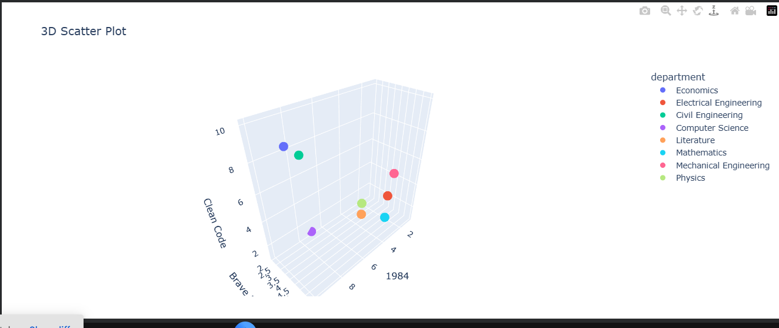

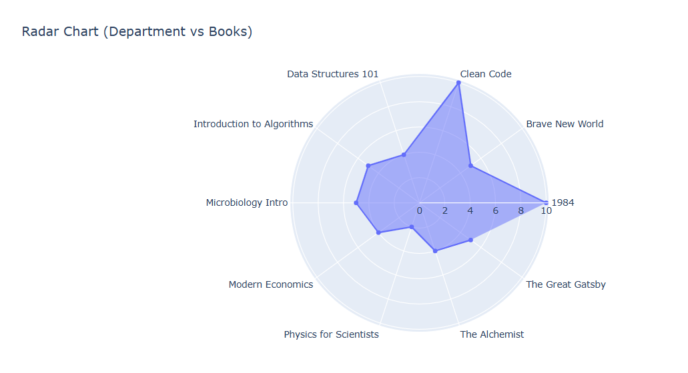
CONCLUSION

The Library Management System project successfully demonstrates the integration of Python programming with data analysis to create a practical, real-world application. The system automates core library operations — book issuance, return processing, late fee calculation, and receipt generation via email — eliminating the need for manual record-keeping.

The data analysis component, spanning Experiments 10 through 18, covers the complete data science workflow: data loading and exploration, categorical encoding, preprocessing and cleaning, normalization, binning, and an extensive range of visualizations from basic charts to interactive and hierarchical plots.

Based on the analysis of library data, the following key conclusions can be drawn:

- The Pandas and NumPy libraries together provide a robust foundation for all data storage, retrieval, and manipulation operations.
- The email notification system using Yagmail significantly improves student communication and reduces manual effort for library staff.
- Pivot tables and advanced visualizations (Treemaps, Sankey Diagrams) provide actionable insights into which departments borrow which books most frequently.
- Hierarchical clustering (Dendrogram) reveals natural groupings of departments based on similar reading patterns.
- Data normalization techniques (Min-Max, Z-Score) prepare the dataset for any future machine learning applications such as book recommendation systems.

Overall, this project demonstrates that Python — with its rich ecosystem of data science and visualization libraries — is an exceptionally powerful tool for developing practical management systems with built-in analytical capabilities.

